|  |
| --- |
| Image result for nuclear fuel complex logo |
| **PROJECT WORK:**  **Automating Systems Using Arduino** |
| SUBMITTED |
| By |
| **Talla Kusuma Reddy** |
| IV Yr. B. Tech |
| DEPT. OF ELECTRICAL AND ELECTRONICS ENGINEERING |

|  |
| --- |
| **Narasaraopeta Engineering College – Narasaraopeta, Andhra Pradesh**  24th February 2025 to 23rd March 2025 |
|  |

|  |
| --- |
|  |
| Department of Atomic Energy  NUCLEAR FUEL COMPLEX |

**BONAFIDE CERTIFICATE**

This is to certify that Ms. Talla Kusuma Reddy have done their Project Work under my guidance during the period 24/02/2025 to 23/03/2025 on the topic entitled **Automating Systems Using Arduino** in Nuclear Fuel Complex.

It is ensured that the report does not contain classified or plant operational live data in any form.

|  |  |
| --- | --- |
|  | Signature: |
|  | Name: B. V. ArunKiran |
| Hyderabad | Designation of Guide: Deputy Manager |
| Date: | Plant: Equipment Development & Automation |

|  |
| --- |
| Approved by |
| General Manager, ED&A |

**ACKNOWLEDGEMENT**

First of all, I am extremely thankful to Shri Dr. Komal Kapoor, Chairman, NFC Board & Chief Executive, NFC for giving me this opportunity to carry out Internship at Nuclear Fuel Complex.

I would like to express our sincere thanks to Shri B.V Arun Kiran (Deputy Manager, ED&A) for accepting to be our Guide and helping us throughout our internship.

I profoundly thank Shri N. Rajesh, GM (ED&A) allowing us to do the internship in the plant.

I would like to thank Shri A. Maruthi Ram, DCE (TP & ED&A) for facilitating our internship.

I express our sincere thanks to Shri V. V. Mahesh Kumar, DCE (Safety, HPU, TLD & HR) and Shri D. Srinivas, AGM (HRD, Q. Cir., & QIS) for helping me throughout our internship at NFC and also conducting Awareness Programme on DAE/NFC activities at HRD.

My special thanks to our professor Mrs. Lalitha P, HOD, Dept. of Mechanical Engineering,Rajiv Gandhi University of Knowledge Technologies-Basar who has given me this opportunity and their guidance.

I am grateful to my parents who have given me constant encouragement and inspiration to pursue my graduation.

Finally, I would like to thank everyone who has directly and indirectly helped us in the successful completion of this internship.

Contents

1. INTRODUCTION 5

1.1 ABOUT NFC: 5

1.2 SCOPE: 5

1.3 NUCLEAR FUEL: 6

1.4 MAKING OF NUCLEAR FUEL: 6

1.5 ZIRCALOY PRODUCTION: 7

1.6 FUEL FABRICATION: 7

1.7 SELF RELIANCE: 7

1.8ABOUT ED&A: 8

1.9 Process Plan: 8

2. LITERATURE REVIEW 10

2.1DIFFERENT CAD PACKAGES: 10

2.2 SERVO MOTORS 15

2.3 PNEUMATIC GRIPPERS 17

2.4 PNEUMATIC CYLINDERS 18

2.5 BEARINGS 20

2.6 SHAFTS 21

3. CAD MODELING 23

3. 1 DESIGN: 23

3.2 PROBLEMS FACED 23

4. Conclusion 26

5. References 26

# 1. INTRODUCTION

## 1.1 ABOUT NFC:

The Nuclear Fuel Complex (NFC), established in 1971, is a key industrial unit of the Government of India's Department of Atomic Energy. The facility is in charge of supplying nuclear fuel bundles and reactor core components to all of India's nuclear power reactors. It is a one-of-a-kind factory that produces natural and enriched uranium fuel, zirconium alloy cladding, and reactor core components all under one roof, beginning with raw materials.

## 1.2 SCOPE:

The Nuclear Fuel Complex is unique in many respects. It is the only Complex of its kind where Uranium concentrates on the one hand and Zirconium mineral on the other are processed at the same location all the way to produce finished fuel assemblies and also zirconium alloy tubular components, for supplies to the Nuclear Power Industry. The complex also symbolizes the strong emphasis on self-reliance in the Indian Nuclear Power Programme. The advanced technologies for the production of nuclear grade uranium di-oxide fuel, zirconium metal and zirconium alloy tube components and the manufacture of fuel bundles conforming to reactor specifications were developed through systematic efforts during the late 50's and the 60's.

The complex has different types of production facilities which include the Zirconium Oxide Plant for processing of Zircon to pure Zirconium oxide; the Zirconium Sponge Plant for conversion of Zirconium oxide to pure sponge metal; facilities for reclamation of zircaloy mill-scrap; the Zircaloy Fabrication Plant for producing various zirconium alloy tubing’s and also sheet, rod and wire products; the Uranium Oxide Plant for processing crude uranium concentrate to pure uranium di-oxide powder; the Ceramic Fuel Fabrication Plant for producing sintered Uranium oxide pellets and assembling of the fuel bundles for the PHWRs; the Enriched Uranium Oxide Plant for processing of imported enriched uranium hexafluoride to enriched uranium oxide powder; the Enriched Uranium Fuel Fabrication Plant for producing enriched UO2 pellets and the fuel assemblies for the BWR reactors; and a plant for fabrication of components and sub-assemblies for Fast Breeder Reactors. A Special Materials Plant for producing a number of electronic grade high purity materials for supplies to the Electronic Industry and plants producing stainless steel seamless and other special tubes have also been set up in this complex.

The common plant facilities comprising of the Quality Control Laboratory, the Central Workshop, the Compressor and Boiler House, the Civil, Electrical and Mechanical Engineering Services render strong support to the Plant operations.

While the individual plant capacities were designed to match the requirements of the Indian Nuclear Power Programme as projected in the early '70s the capacities have been under continuous review. With the experience gained in the operation of various production plants, process and equipment modifications have been incorporated to progressively improve plant performance. The stage has now been reached for substantial increase in capacities and plans have been drawn up for establishing new plants to cater to the requirements of fuel and zircaloy for the 6,000 Mwe Indian Nuclear Power Programme to be implemented in this decade.

An important feature at the Nuclear Fuel Complex, is that, apart from indigenous process development, a good portion of the plant equipment for the chemical engineering and extractive metallurgy operations has been indigenously designed and fabricated by the Indian industry. Even in the case of fabrication plants, sophisticated equipment such as Vacuum Annealing Furnace, the Pilger mill, the High Temperature Hydrogen welding units have been successfully designed and fabricated in-house.

## 1.3 NUCLEAR FUEL:

India is developing a three-stage indigenous nuclear power programme that includes closed fuel cycles of Pressurized Heavy Water Reactors (PHWRs) and Liquid Metal Cooled Fast Breeder Reactors (LMFBRs) to make the best use of the comparatively limited uranium deposits and large thorium resources. The initial step of the Power plan is PHWRs, which employ zircaloy as clad and natural uranium dioxide as fuel. Furthermore, India has been running two Boiling Water Reactors (BWRs) since 1969. NFC manufactures zircaloy clad enriched uranium oxide fuel elements and assemblies for these reactors using imported enriched uranium hexafluoride.

## 1.4 MAKING OF NUCLEAR FUEL:

Natural Uranium is mined in Jharkhand at Jaduguda. At the Nuclear Fuel Complex, it is processed into nuclear fuel assemblies. Natural uranium dioxide weighs around 15.2kg in a 220 MW PHWR fuel unit. Uranium dioxide pellets produce heat and fission products while undergoing fission. Fission products are radioactive, and they should be kept apart from cooling water. As a result, the UO2 pellets are housed in Zirconium alloy tubes with hermetically sealed ends.

A 220 MWe reactor unit comprises 3,672 of these fuel assemblies. They are usually replaced after roughly 18 months in the reactor. Careful design and meticulous quality control protect against service failures.

There is no combustion in uranium fuel, and a fuel assembly exits the reactor in the same manner that it entered. However, there is one significant difference: when a fuel assembly is withdrawn from the reactor after approximately 18 months of usage, it retains radioactive by-products from the fission process. Because of the radioactivity, the fuel assembly is transferred to a water-filled pool inside the station using a remote-controlled fuel assembly loading/unloading system.

1. Depleted Uranium (approximately 98%) is stored in fast breeder reactors for recycling.

2. Plutonium (approximately 0.4%) is created when neutrons are absorbed in non-fissile uranium atoms. This is extremely precious and can be used to power rapid reactors.

3. A small percentage of long-lived radioactive fission products is vitrified and preserved.

## 1.5 ZIRCALOY PRODUCTION:

The source mineral for zirconium metal manufacturing is zircon (zirconium silicate), which is found in beach sand deposits in Kerala, Tamil Nadu, and Orissa and is provided by the Indian Rare Earths Ltd. To obtain zirconium oxide, zircon sand is subjected to caustic fusion, dissolution, solvent extraction (to remove hafnium), precipitation, and calcination procedures. To obtain a homogenous zirconium sponge, the pure zirconium oxide is treated to high temperature chlorination, reactive metal reduction, and vacuum distillation. The sponge is then briquetted with alloying materials and vacuum arc melted numerous times to produce homogeneous zircaloy ingots, which are subsequently extruded, pilgered, and finished into seamless tubes, sheets, and bars.

## 1.6 FUEL FABRICATION:

The cylindrical UO2 pellets are stacked and enclosed in thin walled zirconium alloy tubes for PHWR fuel, with both ends sealed by resistance welding with zircaloy end plugs. A number of these fuel pins are joined together to form a fuel bundle that may be easily put into the reactor. The fuel bundles for PHWR 220 MW and PHWR 500 MW each have 19 and 37 fuel pins. There are two types of array fuel assemblies for BWRs: 6x6 and 7x7.

## 1.7 SELF RELIANCE:

The Nuclear Fuel Complex is a prime example of a successful translation of indigenously created procedures to large-scale operations. The country's high self-reliance in the critical area of nuclear fuel and core components is a major asset in not only supporting the nuclear power programme but also establishing a huge number of allied and ancillary sectors..

## 1.8ABOUT ED&A:

The EQUIPMENT DEVELOPMENT AND AUTOMATION (ED&A) branch was established in the early 1980s in response to challenges in importing special purpose welding equipment required for PHWR fuel assembly manufacturing due to the embargo imposed on India by developed countries. Beginning with special-purpose welding equipment, this sector has grown to develop a wide range of machines for specialized purposes in nuclear fuel manufacture.

This plant is critical for the original creation of special purpose equipment for a variety of applications based on user requirements. This division has successfully developed many machines during the last few decades. Certain new technologies, such as empty tube welding, were developed as part of the process of constructing full equipment.

This section's classic special purpose machines, along with their applications, are detailed below.

1. Welding machines for tiny appendages (35mm x 2.5mm x 1mm, 9mm x 2.5mm x 0.6mm) on thin-walled zircaloy tubes (thickness: 0.4mm)

2. Strength testing devices for determining the shear strength of appendage and tube weld joints

3. Graphite coating equipment for coating the inner surface of thin-walled tubes with a few microns of graphite.

4. Granule Transfer System with no leaks for transferring granules to a height of 4 metres.

5. Powder conveyance through flexible screw conveyors

In addition to the foregoing, this section is involved in the automation of intra-product transfer systems.

## 1.9 Process Plan:

The following is the typical flow chart followed for development of special purpose machines. All the projects may not necessarily have all steps.

1. Project starts with getting requirement from the user section having complete specifications

2. Field study of the engineers to understand & enrich the user requirement

3. Conducting Conceptual & feasibility studies

4. Development of concept / prototype study of the machine

5. Design of the machine / gadget with complete sequence of operations

6. Presenting the concept & design to the user for feedback & approval

7. Development of fabrication drawings & control system for the machine

8. Procurement of standard items required for assembly of the machine

9. Fabrication of components & assembly of the machine

10. Testing of the operational & safety features of the machine in automatic & manual modes

11. Installation & Commissioning of the machine at user section

12. Maintenance & performance monitoring of the machine for a period of 1 year after commissioning

13. Preparation of Operation & Maintenance manuals and handling over the machine to maintenance group of the user section.

# 2. LITERATURE REVIEW

## 2.1DIFFERENT CAD PACKAGES:

There are so many packages for 3D Solid Modeling. Some of them are;

* SolidWorks
* AutoCAD
* Fusion 360°
* CATIA
* Tinkercad
* Rhinoceros 3D etc..,

**Solid Works:**

Solid Works is a solid modeling Computer Aided Design (CAD) and Computer Aided Engineering (CAE) application published by Dassault Systems. It was founded in December 1993 by **Jon Hirschtick** who was a graduate of Massachusetts Institute of Technology. Solid Works currently markets several versions of the Solid Works CAD software in addition to e-Drawings, a collaboration tool, and Draft Sight, a 2D CAD product.

**Modelling Technology:**

Solid Works is a solid modeler, and utilizes a parametric feature-based approach which was initially developed by PTC (Creo/Pro-Engineer) to create models and assemblies. The software uses the Parasolid modeling kernel.

Building a model in Solid Works usually starts with a 2D sketch (although 3D sketches are available for power users). The sketch consists of geometry such as points, lines, arcs, conics (except the hyperbola), and splines. Dimensions are added to the sketch to define the size and location of the geometry. Relations are used to define attributes such as tangency, parallelism, perpendicularity, and concentricity. The parametric nature of Solid Works means that the dimensions and relations drive the geometry, not the other way around.

In an assembly, the analog to sketch relations are mates. Just as sketch relations define conditions such as tangency, parallelism, and concentricity with respect to sketch geometry, assembly mates define equivalent relations with respect to the individual parts or components, allowing the easy construction of assemblies. Solid Works also includes additional advanced mating features such as gear and cam follower mates, which allow modeled gear assemblies to accurately reproduce the rotational movement of an actual gear train. Finally, drawings can be created either from parts or assemblies. Views are automatically generated from the solid model, and notes, dimensions and tolerances can then be easily added to the drawing as needed.

SOLIDWORKS Premium builds on SOLIDWORKS Professional by adding structural and motion analysis capabilities, advanced surface flattening, reverse engineering, and electrical cable and pipe routing functionality.

The software has the following features.

|  |
| --- |
| **Part & Assembly Modelling** |
| 3D Solid Modelling |
| Feature Manager design tree in Assembly |
| Large Assembly Design |
| Sheet Metal Design |
| Plastic Part Design |
| Direct Model Geometry Modification |
| Advanced Surface Design |
| Weldments |
| Mould Design |
| **2D Drawing** |
| Automatic Drawing View Creation |
| Drafting Standards ISO, DIN, ANSI, JIS, BSI, GOST, GB |
| Annotations & Symbols |
| Hole Tables, Pipe Bend Tables, Weld Tables & Cut Lists |
| Automated Creation of Exploded Views |
| Automatic Drawing View Updates |
| Manual and Automated Dimensioning & Tolerancing |
| Automatic Bill of Materials (BOM), Exploded Views, Balloons & Notes |
| Sheet Metal Bend Notes |
| **Design Reuse & Automation** |
| SOLIDWORKS Search |
| Part & Assembly Configurations |
| 3D CAD Models from other sources |
| Design Automation (DriveWorksXpress) |
| Re-use 2D and 3D CAD Data |
| **Animation & Visualization** |
| Move Assembly by Dragging Components |
| CAD Videos |
| 3D Walkthrough |
| Collision & Interference Detection |
| Move Assembly with Motors |
| Basic CAD Rendering (RealView) |
| Hole Alignment and Thread Checks |
| **Collaborate and Share CAD Data** |
| 3D Interconnect for Associative Import of 3D Models |
| Import/Export Over 30 CAD Formats |
| MCAD to AEC: Prepare and export to AEC applications |
| View eDrawings Files |
| 2D DXF/DWG Data |
| 2D to 3D CAD Conversion Tools  Intellectual Property Protection |
| Read Printed Circuit Board Data as 3D Parts (IFC) |
| Print directly to 3D printers: AMF and 3MF formats |
| 3D Models for CAD/CAM Integration with CAM Partners |
| 3D Dimensioning and Tolerancing (Model Based Definition) |
| Maintain and Update Existing 2D Drawings – edit and view DWG files in Draft Sight |
| Convert 3D Solid Parts to Sheet Metal  Design Review Markup and Viewing (Large Design Review) |
| **Interference Check** |
| Check for interferences, collisions and clearances between components in the design |
| Available both in 2D & 3D |
| **First-Pass Analysis** |
| SimulationXpress for performing basic stress analysis on individual parts |
| **CAM Programming (Solidworks CAM)** |
| Integrated 2.5-axis milling programming solution powered by CAMworks |
| Full simulation of machining operations |
| Automatically create optimum tool path based on Machine, Material, Cutting Tools and 3D Model |
| **Design for Manufacturing** |
| Thickness Analysis |
| Compare Parts and Drawings for Changes |
| Draft and Undercut Analysis |
| CAD Libraries (Standard Fasteners and Components (Toolbox) |
| Automatic Assembly of Fasteners and Components |
| Geometry Check for CAM |
| Rules-based Manufacturability Checks (DFMXpress) |
| Sheet Metal Checks and Flat Pattern |
| Beam, Bearing, and Cam Design Wizard |
| Automatic Task Scheduling and Batch Processing |
| **Productivity Tools** |
| Power Selection Tool |
| Copy Feature Info into Other Features |
| Symmetry Check |
| Find and Replace in Drawing |
| **Advanced CAD File Import/Export and 3D Interconnect** |
| Interactive Feature Recognition and Conversion |
| Automatic Feature Recognition and Conversion |
| **Xtended reality exporter** |
| **CAD Libraries (Solidworks Toolbox)** |
| Easy accessing, locating, downloading, customizing, saving, and sharing prebuilt 3D CAD models, standard components and commonly reused CAD data |
| Standard components in library shall conform to ANSI, BIS, DIN, ISO & JIS etc |
| Standard components include bearings, bolts, screws, jig, bushings, nuts, o-rings, keys, pins, washers, retaining rings, structural sections, power transmission members etc |
| **Design for Cost (SOLIDWORKS Costing)** |
| Automated Manufacturing Cost Estimation for parts & assemblies |
| Compare Manufacturing Costs |
| Customizable Manufacturing Settings |
| Output Cost Report |
| **ECAD/MCAD Collaboration (CircuitWorks)** |
| Import/Export of Printed Circuit Board (PCB) Designs |
| Two-Way Data Exchange: ECAD to MCAD - MCAD to ECAD IDF, ProStep (IDX) or PADS (*.ASC) |
| Filter Display for Clarification |
| Design Change Notes |
| Automatic Electrical Component Assembly |
| PCB Outlines, Keep-Out Areas, Maximum Heights |
| Compare Board Designs for Differences |
| **CAD Standards Checking (Design Checker)** |
| Verify Designs against Company Standards |
| Customize Design Check Rules |
| Automatically Correct Non-Conforming Issues |
| **Collaboration with eDrawings Professional** |
| Create and Publish eDrawings Files |
| Enable Markup of eDrawings Files |
| View Assembly Animations |
| Allow Measurement in eDrawings Files |
| Exploded Views Support for eDrawings Files |
| Password Protect Intellectual Property |
| **Automated Tolerance Stack-Up Analysis (TolAnalyst)** |
| Worst Case and RSS Maximum/Minimum |
| Automatic Update of Analysis when Design Changes |
| Identify Highest Contributing Tolerances |
| **Advanced Photorealistic Rendering (Solidworks Visualize)** |
| Advanced Photorealistic Rendering (PhotoView 360) |
| Control Camera View, Lighting, Materials, Textures |
| Photo Quality Images and Animations |
| **SOLIDWORKS File Management** |
| User and Group Access Rights |
| File Vaulting |
| Secure Check-in and Check-out |
| Automated Revision Control |
| **Reverse Engineering (ScanTo3D)** |
| Import, Edit, Evaluate, and Create Solid Geometry from Point Cloud and Mesh Data |
| Import Image Files and Convert Raster to Vector Data |
| Import Adobe Illustrator Files |
| **Time-based Motion Analysis** |
| Kinematic and Dynamic Analysis |
| Inputs: Forces, Springs, Dampers, Gravity, Contact, Bushings |
| Outputs: Displacement, Velocities, |
| View/Publish Animations, Graphs, Reports |
| Accelerations, Body Loads, Joint Forces |
| **Linear Static Analysis for Parts and Assemblies** |
| Inputs: Variable Forces/Pressures, Full Restraint Sets, Connectors, Gravity, Contact, Materials |
| Outputs: Factor of Safety, Stress, Displacement, Strain |
| View/Publish Animations, Graphs, Reports |
| **Pipe & Tube Routing and Electrical Cable and Wiring Harness Routing** |
| Create Detailed Piping Systems |
| Customizable Library of Piping Components |
| Output Tube Bend Data for Manufacturing |
| Automatic Routing Option for Pipes and Tubes |
| Create Detailed Electrical Cable and Wiring Harnesses |
| Conduit |
| Wire Lengths Automatically Calculated |
| BOM and Wire Cut Lists |
| Mounting Hardware, Splices, Connectors, Insulation, Looms, Heat-Shrink Tubing, Cable Ties |
| Create Flexible or Rigid Tubing Lines |
| Automatic Assembly of Hangers and Supports |
| Cut Length Calculations Automated for BOM |
| Minimum Bend Radius Check for Tubes |
| Routing of Electrical Cabling and Wiring Harnesses |
| Run Rigid or Flexible Electrical Conduit Segments |
| Automated Harness Flattening for Manufacturing |
| Automatic Routing Using Imported "From-To" Connection Data |
| Routing of Rectangular and Other Sections |

Solid Works introduces some of the most advanced (and impressive) tools in the SOLIDWORKS suite of products. With this license level, we have access to SOLIDWORKS legendary simulation tools at a level similar to purchasing SOLIDWORKS Simulation Standard.

We can also animate how an assembly will move and even collide using Motion Study. When preparing to prototype a product, these tools are especially helpful because they can determine if a design will fail; ultimately eliminating the cost of creating sever first prototypes. There are also features that allow us to route our electrical and plumbing within SOLIDWORKS so we can manage their space effectively, optimize their length, and eliminate waste/cost.

**AutoCAD:**

**AutoCAD** is a computer-aided design (CAD) and drafting software application. Developed and marketed by Autodesk, AutoCAD was first released in December 1982 as a desktop app running on microcomputers with internal graphics controllers. Before AutoCAD was introduced, most commercial CAD programs ran on mainframe computers or minicomputers, with each CAD operator (user) working at a separate graphics terminal. AutoCAD is also available as mobile and web apps. AutoCAD is primarily used for 2 Dimensional drawings, and even though 3D modeling is available in AutoCAD other computer-aided design software like Fusion 360, Inventor and Solidworks are preferred in 3D modeling. AutoCAD is used in industry, by architects, project managers, engineers, graphic designers, city planners and other professionals.

## 2.2 SERVO MOTORS

A servo motor is a type of a motor that is used in various applications like robotics, automation and control systems. It is a rotary actuator that allows for precise control of angular position. Servo motor operates based on feedback control of angular position .servo motors operates based on the feedback control where they receive a signal input to move to a specific position and they adjust their position based on feedback control position and then adjust their position based on feedback from an encoder to reach and maintain that position accurately. This feedback loop enables servo motors to have high precision, accuracy and repeated ability in their movements. They are commonly used in applications where precise control of position, speed and acceleration as required.

Servo motors after classified into two main types AC and DC servo motors. Ac servo motors are typically used in high power applications which DC servo motors are commonly in smaller, 20w power applications, servo motors are known for their ability to provide precise control over position speed and torque.

They are widely used in robotics, CNC machine, 3d printers, and other automated systems where accuracy and control are crucial. Additionally servo is known for their quick response times and ability to maintain a specific position even under varying loads.

**AC SERVO MOTORS:**

AC servo motors are driven by alternative current and are known for their high performance in terms of speed torque and precision control such as in CNC machines, robotics and industrial automation. Ac servo motors typically have closed-loop control systems that continuously monitors feedback signals to adjust the motors performance accurately.

**DC SERVO MOTORS:**

DC servo motors are powered by direct current (DC) and are also. Widely used in various applications DC servo motors are known as for their simplicity ease of control and cost-effectiveness. They are commonly used in smaller scale applications like robotics conveyor systems and positioning systems. DC servo motors also often utilize a closed loop control systems for accurate position and speed control

Servo motors consists of a regular motor coupled with a sensor for feedback control .the sensor for feedback control. The sensor provides information about the motors current position allowing the desired position accurately. This closed loop control systems is what enables servo motors to be so precise and reliable in various applications.

Additionally servo motors can be controlled using different types of signals such as PWM (pulse width modulation), which helps in controlling the speed and position of the motor effectively.

**Construction of servo motors:**

Servo motors typically have a rotor, stator and control circuitry the. The rotor part of the motor, while the station is the stationary part that generates the magnetic field the control circuitry is responsible for interpreting the input signals and adjusting the motors position ratinhto suir differernt applications.

**Models of servo motors:**

1. Simens SIMOTICS-1FK7:- This servo motor series from siemens is known for its high performance, precision and reliability making it suitable for various industrial applications.

2. Allen-bradley kinetix 600:- The kinetix 600 series from allen. Bradely offers advances motion control capabilities and is commonly used in industrial automation systems

3. Yas kawa sigma-7: vas kawa sigma -7 servo motors are re owned for their high-speed performance, accuracy and durability making them a popular choice for industrial applications requiring precision control.

4. mitsubishi Electric MR-J4: Servo motors are known for their high speed performance ,precision control and reliability making them a popular choice industrial applications. These motors are designed to provide excellent motion control capabilities offering fast and accurate movements in various industrial automation tasks.

5. schneider electric lexium 32: the lexium 32 series from schneider electric provides advanced motion control capabilities , reliability and flexibility making it a popular choice for industrial automation systems.

## 2.3 PNEUMATIC GRIPPERS

Pneumatic grippers are mechanical devices used to grasp and hold objects in place, powered by compressed air they are commonly used in industrial automation robotics and manufacturing processes. Here is a detailed over view of pneumatic grippers.

Types of pneumatics grippers:

1. Parallel pneumatic grippers

2. Angular pneumatic grippers

3. Radial grippers

4. Vacuum grippers

5. Magnetic grippers.

1. **Parallel pneumatic gripper**:

In the Parallel pneumatic gripper jaws moves parallel to each other suitable for gripping flat or rectangular object.

1. **Angular grippers:**

In this type of grippers jaw move at an angle, ideal for gripping cylindrical and irregular shaped objects

1. **Radial grippers:**

In this gripper jaw moves radially used for gripping small or delicate objects

1. **Vaccum grippers:**

Using of vaccum suction to grip to object suitable for handling fragile or smooth surface

1. **Magnetic grippers:**

Use magnetic fields to grip ferrous objects.

**Operating principle:**

* Compressed air is supplied to the gripper
* The air pressure moves the piston which actuates the jaws
* The jaws open or close gripping or releasing the object
* The air supply is reversed and the jaws return to their original piston

**Specifications and consideration:**

Gripping force: The amount of force exerted by the jaws

Stroke length: The distance jaws will travel.

Gripping diameter: The maximum objects size that can be gripped

Cycle life : The number of grip release cycles the gripper can perform

**Applications:**

1. Industrial automation

2. Robotics

3. Manufacturing process

4. Assembly lines

5. Material handling

6. Packing machinery

7. Food processing

## 2.4 PNEUMATIC CYLINDERS

Pneumatic cylinders also known as pneumatic actuators, it is a mechanical device that uses compressed air to generate force and motion. It is a fundamental component in pneumatic systems which are widely used in industrial automation, robotics, and process control.

**Construction:**

A cylindrical body made of metal or plastic piston that moves back and forth inside the cylinder. A rod attached to the piston that extends out of the cylinder end caps or mounts that secure the cylinder in place valves or ports for air supply and exhaust

**Operating principle:**

Compressed air is supplied to the cylinder through a valve or port. The air pressure pushes the piston which moves the rod out of the cylinder (extension –stroke) When the air supply is reversed the piston returns to its original position and the rod retracts into the cylinder (retraction stroke)

**Types of pneumatic cylinders**

Single-acting:

Double acting:

Rod less:

Tie-rod cylinders:

Compact cylinders:

**Single-acting:**

This type of cylinders acts in only single direction (extension or retraction)

**Double acting:**

This cylinders will move in both direction (extension and retraction)

**Rod less:**

Don’t have a rod, instead the piston attached to the carriage or slide

**Tie-rod cylinders:**

This cylinders having a rod and a tie rod that connects the piston to the cylinder body

**Compact cylinders:**

Smaller and lighter, often used in tight space.

**Specifications and considerations:**

Bore size

Stroke length

Operating pressure

Force and speed

Mounting styles

Accessories

**Applications:-**

Industrial automation

Robotics

Process control

Material handling

Packaging machinery

Medical devices

Aerospace

## 2.5 BEARINGS

Bearings are the mechanical devices that contain rolling elements such as balls or rollers, that rotates to reduce friction and support loads.

**Types of bearings:**

Ball bearings

Angular contact bearings

Axial or thrust bearings

Deep-groove bearings

**The purpose of bearings:**

The purpose of bearings is to reduce rotational friction and support radial and axial loads. it achieves this by using at least two races to contain the balls and transmit the loads through the balls. In most applications one race is stationary and the other is attached to the rotating assembly (eg.hub or shaft). As one of the bearing races rotates it causes the ball to rotate as well. because the bearing rotates it causes the ball to rotate as well. Because the balls are rolling they have a much lower coefficient of friction than if two flat surfaces were sliding against each other

Ball bearings tend to have lower load capacity for their size than other kind of rolling element bearings due to smaller contact area between the races. However they can tolerate some misalignment of the inner and outer races

**Construction types:**

Conrad: assembly by placing inner ring eccentrically with balls inserted through a gap

Slot-fill: notched races allows balls to be slipped in for assembly

Relieved race: reduced OD or increased ID allows more balls to be assembled.

Fracture race: radially sliced ring allows more balls and support axial loading.

Rows: single row or double-row designs with varying advantages

Flanged: simplifies axial location with flange on the outer ring

Caged: secures balls in conard-style bearings

**Operating conditions:**

Life span: calculated based on load and speed, with industry standards and formulas.

Failures modes: includes plastic deformation, brinelling, and structural collapse.

Maximum load: proportional to outer diameter and width with static load ratings.

Lubrication: essential for operation with recommendation for dynamics viscosity.

**Materials used for bearings:**

Stain less steel

Chrome steel

Ceramics (silicon nitride)

Hybrid (ceramics balls with metal races)

**Applications:**

Industrial automation

Robotics

Manufacturing process

Aerospace

Medical devices

Skate boards

## 2.6 SHAFTS

Shafts are mechanical components that transmit power,motion or torque through rotation.here’s comprehensive overview of shafts

**Types of shafts:**

Transmission shafts

Line shafts

Torsion shafts

Axles

Spindles

**Transmission shafts:**

Connects gears, pulleys, or other components to transmit power.

**Line shafts**:

Support multiple pulleys or gears to distribute power.

**Torsion shafts:**

Twists to transmit torque, often in precision applications.

**Axles:**

Stationary or rotating shafts that support wheels or gears.

**Spindles**

High- speed shafts for machine tools,grinders or drills.

**Construction:**

Materials:

Steel (carbon, alloy, or stainless), aluminum, or specialty materials

Shapes:

Cylindrical, tapered, or stepped

Surface finish:

Varies from rough to precision ground or polished

End configuration:

Keyed splined or threaded ends for connections.

**Designing consideration:**

Length: affects shafts shaft stiffness and critical speed.

Diameter: influence strength, stiffness, and bearings selections

Straightness: impact performances and bearing life

Balance: ensure even weight distribution for smooth operation.

# 3. CAD MODELING

## 3. 1 DESIGN:

The project focuses on transferring the Sintered Pellets from Molybdenum Boat to SS Box at Ceramic Fuel Fabrication Plant (Pelletizing). Sintering is the process of increasing density of the pellets by heating them under controlled atmosphere in a furnace to about 1700o C.

The operation of the unit is based on actuation of four guided cylinders, two each for Moly. Boat & SS box and rotation of the system using geared motor, affecting the transfer of pellets. This machine reduces human efforts and saves a lot of time. Damaging of equipment is also less compared to human handling.

## 3.2 PROBLEMS FACED

The weight of the box is 2.5kgs, weight of the boat is 16kgs, weight of the pellets is 34kgs. Weight of boat with pellets are 50kgs. The total weight of boat, box and pellets are 52.5kgs.

To use a pneumatic gripper,it has to hold and lift the total weight of 52.5kgs. To select the gripper we need the gripping force. To calculate gripping force the formula is,

From free body diagram,

2uF=mg

F=mg/2u

F= (52.5)x1.5x9.81/2x0.3

F=772.5375/0.6

F=1287.56 N

Therefore the gripping force required to hold total weight is 1287.56 N. We gone through few gripper models some of them are,

* Parallel gripper DHPC
* Parallel gripper DHPS
* Radial gripper DHRC
* Electrical Parallel gripper HEPP
* Radial gripper DHRS
* Radial gripper HGRT-32-A
* Parallel gripper HGP
* SMC MHZ2 gripper

After going through many specifications in above mentioned grippers catalogue we realised that the gripping force is less than that is required for the application. So, guided cylinders are used for holding & tilting the boat and box as shown.

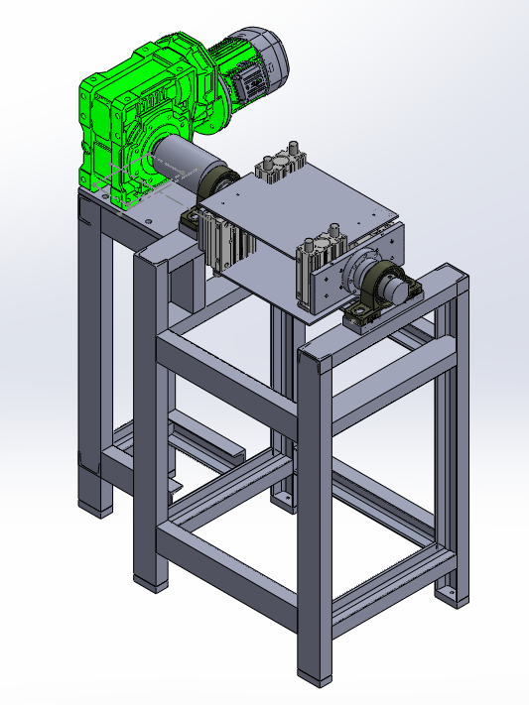

Fig. 3.1: Isometric view of Special Purpose Boat Discharging Machine

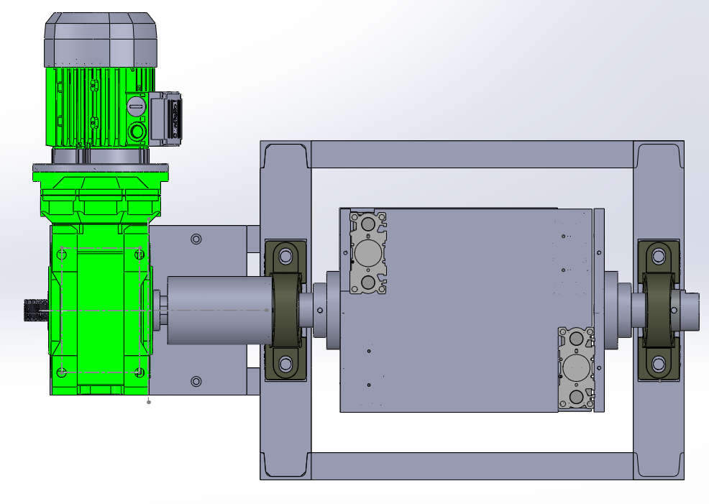

Fig. 3.2: Plan view of Special Purpose Boat Discharging Machine

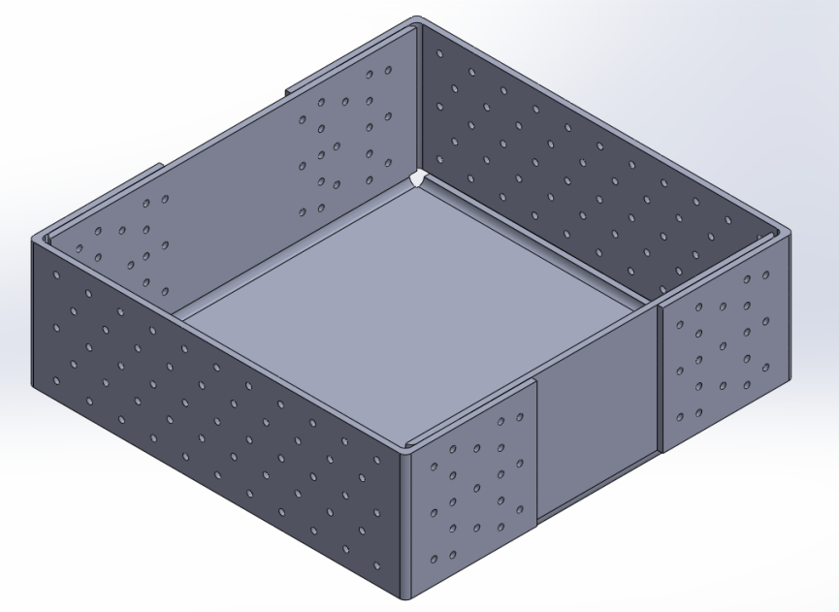

Fig. 3.3: Isometric View of Molybdenum Boat

# 4. Conclusion

- Learnt Solid works software.

- Modelled Special Purpsoe Boat Discharging Machine

-Learnt about design principles and different automation products.

# 5. References

<https://schunk.com/us/en/search/documents?text=gripperss>

<https://www.pneumatictips.com/what-are-single-acting-pneumatic-cylinders/>

https://www.festo.com/in/en/search/?text=actuators

<https://www.festo.com/in/en/>

<https://www.smcusa.com/search?q=grippers>